**BIOPRINTING: A STRATEGY TO BUILD INFORMATIVE MODELS OF EXPOSURE AND DISEASE**

Technical Seminar Documentation Submitted to

**JAWAHARLAL NEHRU TECHNOLOGICAL UNIVERSITY, HYDERABAD**

In partial fulfillment of the requirements for the award of the degree of

**BACHELOR OF TECHNOLOGY**

**In**

**COMPUTER SCIENCE AND ENGINEERING**

Submitted By

**MANIKANTA CHELAMALLA 21UK1A0559**

Under the guidance of

Mrs B. Rajitha

Assistant Professor



**DEPARTMENT OF COMPUTER SCIENCE AND ENGINEERING VAAGDEVI ENGINEERING COLLEGE**

Affiliated to JNTUH, HYDERABAD BOLLIKUNTA, WARANGAL (T.S) – 506005

**DEPARTMENT OF COMPUTER SCIENCE AND ENGINEERING VAAGDEVI ENGINEERING COLLEGE**

**WARANGAL**



**CERTIFICATE**

This is to certify that the Technical Seminar report entitled “**BIOPRINTING:A Strategy To Build Informative Models Of Exposure And Disease**” is being submitted by **MANIKANTA CHELAMALLA(21UK1A0559)** in partial fulfillment of the requirements for the award of the degree of Bachelor of Technology in Computer Science & Engineering to Jawaharlal Nehru Technology University Hyderabad during the academic year 2024-2025.

GUIDE HOD

Mrs.B.Rajitha. DR. R. NAVEEN KUMAR

**ACKNOWLEDGEMENT**

I wish to Take this opportunity to express our sincere gratitude and deep sense of respect to our beloved **DR. SYED MUSTHAK AHAMED**, Principal, Vaagdevi Engineering College for making us available all the required assistance and for his support and inspiration to carry out this Technical Seminar in the institute.

I extend our heartfelt thanks to **DR. R. Naveen Kumar**, Head of the Department of CSE, Vaagdevi Engineering College for providing us necessary infrastructure and thereby giving us freedom to carry out the Technical Seminar.

I express heartfelt thanks to the Technical seminar Coordinator, **Ms. Sushma**, Assistant Professor, Department of CSE for her constant support and giving necessary guidance for completion of this Technical Seminar.

Finally, I express my sincere thanks and gratitude to our family members, friends for their encouragement and outpouring their knowledge and experiencing throughout thesis.

**ABSTRACT**

Bioprinting, a cutting-edge additive manufacturing technique, enables the fabrication of three-dimensional, cell-laden constructs that replicate physiological and pathological environments. This revolutionary technology provides tools to develop in vitro models for disease study, drug development, and chemical safety testing. The paper delves into the mechanisms of bioprinting, covering key techniques such as extrusion-based, inkjet-based, and laser-assisted methods. It highlights the properties and challenges of bioinks, including their rheological behaviour and cell compatibility, and evaluates their applications in modelling diseases such as cancer, liver disorders, cardiovascular conditions, and skin-related issues.

This report identifies key challenges in the field, such as achieving cellular heterogeneity, scalability, and dynamic integration for multi-organ platforms, while proposing future directions, including 4D bioprinting and AI-driven customizations. Bioprinting has the potential to bridge the gap between preclinical research and clinical applications, offering ethical and high-fidelity alternatives to in vivo experiments.

**TABLE OF CONTENTS**

**I. INTRODUCTION…………………………………………………….. 1**

**II.** **BIOPRINTING TECHNIQUES……………………………………. 2-3**

**III. HYDROGELS AND BIOINKS…………………………………….. 4-7**

**IV.** **TISSUE MODELS FOR RESEARCH AND APPLICATIONS …. 8-10**

**V. FUTURE DIRECTIONS IN BIOPRINTING ……………………… 11-12**

**VI.** **CHALLENGES AND ETHICAL CONSIDERATIONS …………. 13-14**

**VII.CONCLUSION…………………………………………………….... 15**

**VIII.REFERENCES……………………………………………………. 16-17**

**I.INTRODUCTION**

Bioprinting is a transformative technology that uses additive manufacturing principles to create three-dimensional, cell-laden constructs that mimic the structure and functionality of native tissues and organs. It involves the precise layering of cells, biomaterials, and biological molecules to produce constructs with high physiological relevance. Over the past decade, bioprinting has emerged as a powerful tool for biomedical research, regenerative medicine, drug testing, and the study of disease mechanisms. By replicating complex biological environments, it allows researchers to overcome the limitations of traditional in vitro and in vivo models.

At its core, bioprinting combines engineering, biology, and material science to fabricate structures with high spatial resolution and cellular heterogeneity. By using computer-aided design (CAD) and automated printing technologies, researchers can achieve unprecedented control over the placement and organization of cells within a biomimetic environment. This precision has made bioprinting a cornerstone in the advancement of tissue engineering and disease modeling.

**History and Evolution:**  
Bioprinting originates from additive manufacturing technologies developed in the 1980s. Early advancements include the first bioprinted organ transplant and pioneering work on extrusion-based printing. By the early 2000s, researchers like Dr. Thomas Boland adapted inkjet printers for depositing bioinks containing living cells, marking a milestone in the evolution of bioprinting.

**Need for Bioprinting in Biomedical Research**

Biological research and clinical studies have long relied on two traditional models: **2D cell cultures** and **animal models**. However, these models face significant limitations:

* **2D Cell Cultures:** While widely used due to their simplicity and cost-effectiveness, 2D cultures fail to replicate the complexity of the three-dimensional microenvironment found in living tissues. This limits their ability to accurately predict cellular behaviour, drug response, and tissue interactions in real-world conditions.
* **Animal Models:** Although more physiologically relevant, animal models often do not fully replicate human biology due to interspecies differences. Additionally, the ethical concerns and high costs associated with animal testing make it imperative to find alternative solutions.

Bioprinting addresses these challenges by offering an intermediate platform that combines the physiological relevance of 3D tissue structures with the reproducibility and scalability of engineered systems. By enabling the fabrication of tissue models with controlled architecture, cell distribution, and biomechanical properties, bioprinting bridges the gap between in vitro and in vivo studies.

1

**II.** **BIOPRINTING TECHNIQUES**

**2.1 Extrusion-Based Bioprinting (EBB)**

EBB involves the deposition of bioinks using a nozzle, driven by pneumatic or mechanical forces. It is highly versatile, supporting a wide range of viscosities. The method is widely used for creating large tissue constructs, such as cartilage and vascularized networks.

**Applications:**

* Printing cell-laden scaffolds for cartilage and bone regeneration.
* Developing vascular networks integrated into tissue constructs.

**Challenges:**

* Limited resolution due to the nozzle diameter.
* Potential shear stress affecting cell viability.

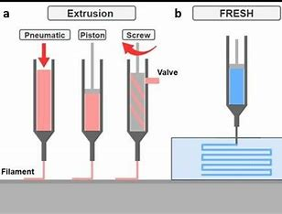

**2**

**2.2 Inkjet Bioprinting**

Inkjet bioprinting employs piezoelectric or thermal forces to eject bioink droplets onto a substrate. This non-contact approach offers high precision and is ideal for printing low-viscosity bioinks.

**Applications:**

* Fabrication of skin equivalents for cosmetic testing.
* Printing microfluidic devices integrated with biological components.

**Challenges:**

* Requires low-viscosity bioinks, which limits its applicability in complex tissue structures.

**2.3 Laser-Assisted Bioprinting (LAB)**

LAB uses laser pulses to transfer droplets of bioinks from a donor surface to a receiver. This method achieves high resolution and is suitable for sensitive cell types, such as stem cells.

**Applications:**

* Printing neural networks for studying brain function.
* Development of corneal implants for ophthalmic applications.

**Challenges:**

* Expensive equipment and slower printing speeds.

3

**III .HYDROGELS AND BIOINKS**

Hydrogels form the foundation of most bioinks due to their unique ability to encapsulate cells while maintaining biocompatibility. They are broadly categorized into natural and synthetic types, each offering distinct advantages and applications in bioprinting.

**Natural Hydrogels**

Natural hydrogels are derived from biological sources and are highly biocompatible. They closely mimic the extracellular matrix (ECM), providing an ideal environment for cell growth and differentiation.

**Collagen**

* Collagen-based hydrogels support cell adhesion, proliferation, and differentiation.
* They are widely used due to their ability to mimic the natural ECM.
* However, they require careful handling to ensure mechanical stability, as they tend to be soft and prone to degradation under certain conditions.

4

**Alginate**

* Derived from seaweed, alginate hydrogels are valued for their ease of cross-linking and excellent structural integrity.
* They can form gels quickly through ionic cross-linking, typically using calcium ions.
* Alginate lacks inherent cell adhesion sites but can be modified to improve cellular interactions.

**Hyaluronic Acid**

* Hyaluronic acid (HA) is a naturally occurring polymer in the ECM, known for its role in tissue hydration and elasticity.
* HA-based hydrogels support cell migration and proliferation and are often chemically modified to enhance their mechanical properties.

5

**Synthetic Hydrogels:**

Synthetic hydrogels are engineered materials that offer tunable properties such as mechanical strength, degradation rates, and biofunctionality. They provide greater control over specific parameters compared to natural hydrogels. These hydrogels can be synthesized through various methods, including physical crosslinking, chemical crosslinking, and irradiation-based crosslinking. They possess distinct properties like high-water content, which mimics natural tissue environments, promoting cell growth and allowing nutrient and waste exchange. Synthetic hydrogels are used in various fields, including biomedicine, sensing, and environmental applications. They serve as scaffolds in tissue engineering, encapsulate and deliver therapeutic agents, and are used in wound healing, cartilage and bone regeneration, and organ-on-a-chip systems. Additionally, these hydrogels can respond to external stimuli such as temperature, pH, and electric and magnetic fields, making them suitable for controlled drug delivery, smart sensors, and actuators. Despite their advantages, synthetic hydrogels face challenges such as insufficient adhesiveness and mechanical strength, which can lead to issues like delamination in applications like supercapacitors, batteries, and solar cells. Synthetic hydrogels continue to be a subject of extensive research due to their versatility and potential in various applications.

6

**Poly(ethylene glycol) (PEG)**

Poly(ethylene glycol) (PEG) is a highly versatile polymer with a wide range of applications, particularly in the field of hydrogels. PEG-based hydrogels can be modified to achieve desired mechanical and chemical properties, offering precise control over cross-linking density, which allows for adjustable stiffness and degradation rates. These hydrogels are often functionalized with bioactive molecules, such as peptides, proteins, and growth factors, to enhance cell adhesion, proliferation, and differentiation. PEG is synthesized through the polymerization of ethylene oxide, resulting in a structure consisting of repeating units of ethylene glycol. Its molecular weight can vary, leading to different properties and applications. PEG hydrogels are known for their excellent biocompatibility and non-immunogenicity, making them ideal for medical applications, including drug delivery systems and implantable devices. They are used in various applications, such as wound healing, drug delivery, and tissue engineering, where they can encapsulate and release therapeutic agents in a controlled manner, providing sustained and localized delivery. Additionally, PEG hydrogels serve as scaffolds for cell growth and tissue regeneration. Due to their versatility and potential in various applications, PEG hydrogels continue to be a subject of extensive research.

7

**IV. TISSUE MODELS FOR RESEARCH AND APPLICATIONS**

Bioprinting has significantly advanced the field of tissue engineering by enabling the creation of 3D models that replicate human tissues' complexity. These models serve as vital tools across various domains of biomedical research, pharmaceutical development, and clinical applications. Below is an expanded view of the applications of bioprinted tissue models, focusing on the liver, cancer, cardiovascular system, and skin.

**Liver Model**

Liver bioprinting focuses on replicating its metabolic and detoxification functions. Advanced models incorporate multiple cell types, such as hepatocytes and Kupffer cells, to mimic the liver microenvironment.

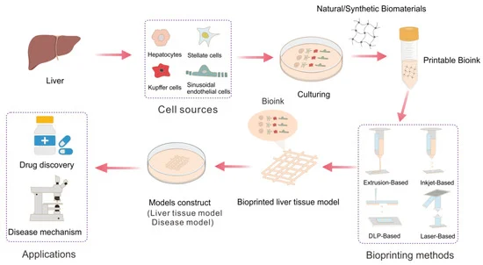

**Case Study**

A bioprinted liver-on-a-chip model demonstrated improved metabolic activity compared to 2D cultures.

8

**Cancer Models**

Bioprinted cancer models allow for the study of tumor microenvironments, including cell-matrix interactions and drug resistance mechanisms. Patient-derived cells have been used to create personalized tumor constructs.

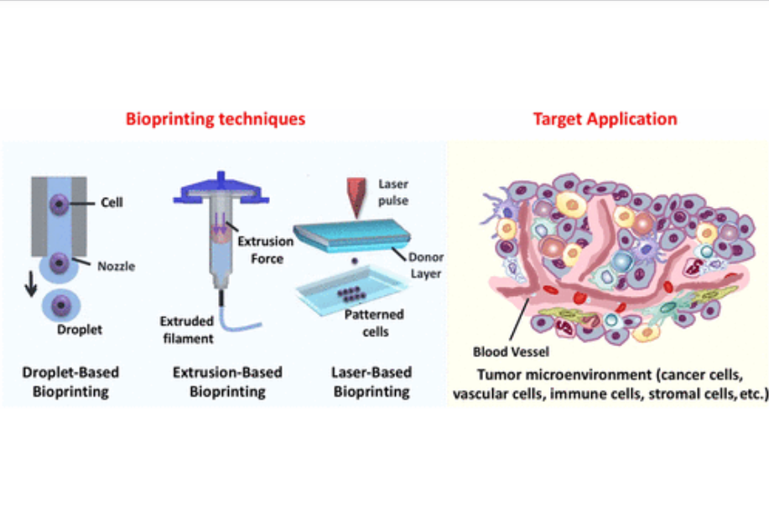

**Cardiovascular Models**

Bioprinted cardiovascular tissues replicate myocardial contractility and vascular networks. These models are critical for cardiotoxicity testing and regenerative medicine applications.

9

**Skin Models**

Bioprinted skin constructs include layers like the epidermis and dermis, with applications in cosmetic testing and wound healing. Recent models incorporate appendages such as hair follicles and sebaceous glands.

10

**V .** **FUTURE DIRECTIONS IN BIOPRINTING**

**Multiorgan Platforms:**

They are emerging as a groundbreaking advancement in bioprinting, aiming to replicate the interconnectedness of human organs and their interactions. By developing platforms that integrate multiple tissues or organs in a single, functional model, researchers can better study how different organs communicate and respond to various stimuli, such as drug exposure or disease progression. These interconnected tissue models could transform drug testing and disease research by providing more accurate, dynamic simulations of human physiology.

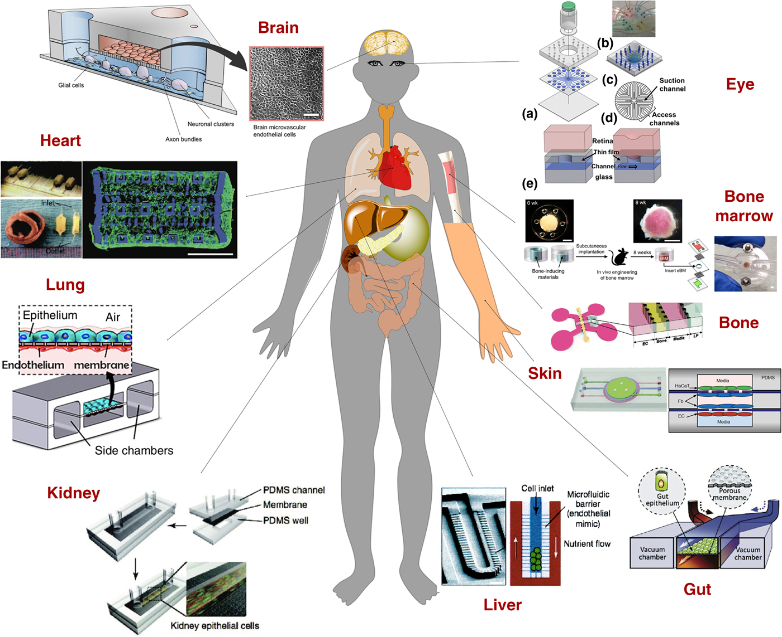

11

**4D Bioprinting** :

4D Bioprinting is an exciting development that incorporates the factor of time into bioprinted constructs, allowing them to change shape or function in response to external environmental stimuli. This dynamic approach adds a new layer of versatility to bioprinting, enabling the creation of tissues and organs that can adapt to conditions such as temperature, pH, or mechanical forces, further enhancing their realism and functionality in applications like personalized medicine, regenerative therapy, and disease modeling. Together, these innovations pave the way for more sophisticated, adaptive, and representative models of human biology.

12

**VI .** **CHALLENGES AND ETHICAL CONSIDERATIONS**

Bioprinting technology holds immense promise for advancing the fields of medicine, drug discovery, and tissue engineering. However, as with any cutting-edge technology, there are significant challenges and ethical considerations that need to be addressed. These challenges range from technical limitations in bioprinting to societal concerns about the creation of artificial tissues and organs.

**Challenges**

1. **Achieving Structural Complexity and Scalability**

One of the biggest challenges in bioprinting is creating tissues and organs that resemble the complexity of human biology. This involves several factors:

* + **Vascularization (Blood Vessels):** Tissues need blood vessels to survive and function, which is difficult to replicate in bioprinted models. Larger organs, like the liver or heart, need a full network of blood vessels to thrive.
  + **Cell Organization:** Human tissues are made up of various cell types organized in specific patterns. Printing tissues that mimic this organization is a complex task and is essential for maintaining tissue functions.
  + **Scalability:** While bioprinted models work on a small scale, making larger tissues and organs is much more challenging, especially in ensuring they are functional and viable.

1. **Ensuring Long-Term Viability and Functionality**

For bioprinted tissues to be useful in research or for medical purposes, they must stay alive and function over time. This includes:

* + **Cell Survival:** The printing process can damage cells, and once printed, they need proper conditions to survive, including nutrients and oxygen.
  + **Maintaining Functionality:** Tissues must continue to perform their natural functions. For instance, a printed liver must still be able to metabolize drugs, and a printed heart tissue must contract.

13

**Ethical Considerations:**

While bioprinting offers numerous advantages, it also raises several ethical concerns, particularly in the context of artificial tissue and organ creation. Balancing the potential benefits of these technologies with ethical implications is essential for the responsible advancement of the field.

1. **Balancing Innovation with Ethical Concerns**
   * **Creating Artificial Organs:** Bioprinted organs could help solve organ shortages for transplants, but there are concerns about the ethical implications of creating organs for use in humans. How should these organs be regulated, and what are the risks of exploitation?
   * **Human Enhancement:** There are concerns that bioprinting might be used for human enhancement, such as creating genetically modified tissues. This could lead to ethical issues about fairness and inequality.
2. **Addressing Regulatory Hurdles**

Bioprinting is a new field, and existing laws and regulations don’t yet cover all its uses. Some of the main concerns are:

* + **Approval for Medical Use:** Government agencies like the FDA will need to set rules for testing and approving bioprinted tissues and organs to ensure they are safe and effective for use in medicine.
  + **Intellectual Property:** As bioprinting becomes more common, questions will arise about who owns the rights to bioprinted tissues and how they should be shared or sold.
  + **Ethical Oversight:** Governments and researchers will need to ensure that bioprinting technologies are used responsibly and fairly, protecting patients and ensuring access to treatments.

14

### VII. CONCLUSION

Bioprinting represents a transformative tool for advancing medical research and therapeutic applications, with the potential to revolutionize drug development, disease modeling, and organ regeneration. While challenges persist, such as achieving tissue complexity, ensuring long-term viability, and creating functional vascular networks, continuous advancements in bioinks, printing techniques, and structural designs are pushing the boundaries of what is possible. The future of bioprinting lies in the development of dynamic, multiorgan systems that replicate human physiology at unprecedented levels of fidelity. These systems could enable more accurate drug testing, personalized medicine, and ultimately, the creation of functional organs for transplantation. As research progresses, the integration of bioprinted tissues and organs into clinical practice may not only improve treatments but also pave the way for groundbreaking therapies in regenerative medicine, offering hope for patients with conditions that currently have no effective solutions.

15

**VIII.REFERENCES**

[1] Center for Devices and Radiological Health, U.S. Food and Drug Administration, “In vitro companion diagnostic devices - Guidance for industry and food and drug administration staff,” 2014. Accessed: Sep. 14, 2020. [Online]. Available: https://www.fda.gov/media/81309/download

[2] Official Journal of the European Union L, “Regulation (EU) 2017/746 of the European Parliament and of the Council of 5 April 2017 on in vitro diagnostic medical devices and repealing directive 98/79/EC and Commission decision 2010/227/EU,” OJ L 117, May 2017. Accessed: Sep. 14, 2020. [Online]. Available: https://eur-lex.europa.eu/legal-content/EN/TXT/PDF/?uri=CELEX:32017R0746&from=EN

[3] M. Abercrombie, “Ross Granville Harrison, 1870-1959,” Biographical Memoirs Fellows Roy. Soc., vol. 7, pp. 110–126, 1961, doi: 10.1098/rsbm.1961.0009.

[4] J. M. Lee et al., “A three-dimensional microenvironment alters protein expression and chemosensitivity of epithelial ovarian cancer cells in vitro,” Lab. Investigation, vol. 93, no. 5, pp. 528–542, May 2013.

[5] B. Yao et al., “Biochemical and structural cues of 3D-printed matrix synergistically direct MSC differentiation for functional sweat gland regeneration,” Sci. Adv., vol. 6, no. 10, Mar. 2020, Art. no. eaaz1094.

[6] B. Vagaska, O. Gillham, and P. Ferretti, “Modelling human CNS injury with human neural stem cells in 2- and 3-Dimensional cultures,” Sci. Rep., vol. 10, no. 1, Apr. 2020, Art. no. 6785.

[7] M. Persson et al., “Osteogenic differentiation of human mesenchymal stem cells in a 3D Woven Scaffold,” Sci. Rep., vol. 8, no. 1, pp. 1–12, Jul. 2018.

[8] D. Zujur, K. Kanke, A. C. Lichtler, H. Hojo, U.-I. Chung, and S. Ohba, “Three-dimensional system enabling the maintenance and directed differentiation of pluripotent stem cells under defined conditions,” Sci. Adv., vol. 3, no. 5, May 2017, Art. no. e1602875.

[9] P. DelNero et al., “3D culture broadly regulates tumor cell hypoxia response and angiogenesis via pro-inflammatory pathways,” Biomaterials, vol. 55, pp. 110–118, Jul. 2015.

[10] D. Zhang, M. Pekkanen-Mattila, M. Shahsavani, A. Falk, A. I. Teixeira, and A. Herland, “A 3D Alzheimer’s disease culture model and the induction of P21-activated kinase mediated sensing in iPSC derived neurons,” Biomaterials, vol. 35, no. 5, pp. 1420–1428, 2014, doi: 10.1016/j.biomaterials.2013.11.028.

[11] S. Thippabhotla, C. Zhong, and M. He, “3D cell culture stimulates the secretion of in vivo like extracellular vesicles,” Sci. Rep., vol. 9, no. 1, Sep. 2019, Art. no. 13012.

[12] R. J. Klebe, “Cytoscribing: A method for micropositioning cells and the construction of two- and three-dimensional synthetic tissues,” Exp. Cell Res., vol. 179, no. 2, pp. 362–373, Dec. 1988.

[13] A. Atala, “Tissue engineering of human bladder,” Brit. Med. Bull., vol. 97, pp. 81–104, 2011.

[14] W. C. Wilson and T. Boland, “Cell and organ printing 1: Protein and cell printers,” Anat. Rec., vol. 272A, no. 2, pp. 491–496, 2003, doi: 10.1002/ar.a.10057.

[15] K. Jakab, A. Neagu, V. Mironov, R. R. Markwald, and G. Forgacs, “Engineering biological structures of prescribed shape using self-assembling multicellular systems,” Proc. Natl. Acad. Sci. USA, vol. 101, no. 9, pp. 2864–2869, Mar. 2004.

16

[16] K. Karzyński et al., “Use of 3D bioprinting in biomedical engineering for clinical application,” Med. Stud., vol. 34, no. 1, pp. 93–97, 2018, doi: 10.5114/ms.2018.74827.

[17] R. R. Jose, M. J. Rodriguez, T. A. Dixon, F. Omenetto, and D. L. Kaplan, “Evolution of bioinks and additive manufacturing technologies for 3D bioprinting,” ACS Biomater., Sci. Eng., vol. 2, no. 10, pp. 1662–1678, 2016, doi: 10.1021/acsbiomaterials.6b00088.

[18] Standard Terminology for Additive Manufacturing General Principles Terminology, ISO/ASTM 52900-2015

17